Predicting Body Fat percentage in Men: A comparative analysis of regression models

* GATTU VAMSHI KRISHNA
* Correspondence: vamshigattu1109@gmail.com
* SR University

**Abstract**

This exploration presents a careful assessment of relapse models for precisely anticipating muscle-to-fat ratio (BFP) in men. Different relapse strategies, including Decision tree Relapse, Elastic net Relapse, Arbitrary Timberland Regressor, Backing Vector Regressor (SVR), K-Neighbours Regressor, and multi-facet perceptron, are investigated.

Obesity, which is linked to serious medical conditions like cancer, diabetes, and heart disease, is frequently caused by an excess of body fat. Exact estimation of the muscle-to-fat ratio is urgent for general wellbeing and wellness. Nonetheless, conventional strategies, for example, submerged weighing, can be expensive and not practical.

Moreover, this study offers a smart investigation of each model's assets and shortcomings, giving significant direction to improving muscle versus fat ratios. By propelling the comprehension of relapse-based approaches for muscle versus fat ratio expectations, this examination offers the advancement of reasonable and practical strategies for evaluating body structure and advancing generally speaking wellbeing in men.

Exact estimation of muscle to fat ratio is fundamental for surveying generally speaking wellbeing and wellness. Nonetheless, customary techniques, for example, submerged weighing, are frequently badly arranged and exorbitant. This examination intends to foster prescient conditions for assessing muscle versus fat ratios utilizing effectively available body circuit estimations.

The dataset utilized in this study comprises of 252 men, with estimations not entirely settled from submerged gauging, body perimeter estimations, age, weight, and level. Different relapse methods are utilized to lay out connections between muscle to fat ratio and the indicator factors. The outcomes give prescient conditions that offer a helpful and financially savvy elective for assessing muscle to fat ratio.

*Keywords: body fat percentage, Decision tree regression, body circumference measurements, underwater weighing, Random Forest regression*

**I. Introduction**

Throughout recent years, cancer, heart illness, and diabetes have been accounted for as driving foundations for death in many nations around the globe. The justification for this is that weight and the excess of muscle to fat ratio prompt obesity. Therefore, how to keep away from stoutness has turned into a vital issue.

One of the most important quantitative indicators that expresses body composition in terms of the presence of body fat is the body fat percentage. People who have a higher body fat percentage are more likely to have diseases like diabetes, heart disease, and obesity. As the sole objective of getting more fit isn't just to manage the midsection line or some other body viewpoint; however, to accomplish great wellbeing and prosperity, muscle versus fat ratio estimation becomes central. As a result, the traditional method of measuring body fat using underwater weighing would be ignored due to its severe drawbacks, inability to afford it, lack of applicable equipment, and lack of trained operators.

In this manner, there will be a numerical structure of basic and minimal expense computations to gauge the degree of muscle versus fat. Even though there are some, traditional methods like underwater weighing can be difficult to use and expensive. However, thanks to machine learning, we can now create much smarter models. We are able to analyse BFP and discover patterns that enable us to more accurately predict BFP by employing methods such as Linear Regression, Decision Trees, Random Forests, and others.

The strategy of working out muscle versus fat ratio might be executed with relapse examination, which utilizes genuine individual's estimations, like for example perimeter, which can undoubtedly be gotten. In the past work, it has been shown the way that the size of some body estimations can be utilized as a decent substitute, for instance, the midriff perimeter shows the level of muscle versus fat. Although there aren't many studies on how these men's body measurements can accurately estimate body fat percentages, they are useful for identifying women who are more likely to suffer from health issues.

By analysing a set of data that includes multiple body circumference measurements and body density measurements from underwater weighing, our goal in this paper is to fill this void. This discrete information comprises 252 male members. It is the utilization of relapse examination methodology of the full-estimations type to foster the conditions of the muscle to fat ratio level from the estimations made. My exploration question connects with the impact component of different body outline estimations on the appraisal of muscle versus fat ratio in men. We, first and foremost, are zeroing in on the nailing down of different most valuable and clear rules that utilize these estimations and give exact muscle versus fat ratio assessments

**II. Literature Review**

Without a doubt, the immediate connection of the muscle versus fat ratio to general wellbeing and wellness requires the body plan to offer the most dependable and exact strategy in evaluating the muscle versus fat ratio, and these techniques are broadly explored.

Undefined Conventional Strategies: The overwhelming aspects of this exemplary strategy created to quantify muscle to fat ratio are the immediate estimation techniques, for example submerged gauging, skinfold thickness estimations, and the bioelectrical impedance examination. Simultaneously, this brings extraordinary certainty.

One side of the coin is that they are very serious, high-cost, mind-boggling, and muddled, in addition to the need for a particular expert a while later. Relapse Strategies: Proportions of body boundary, including other accessible procedures, have been figured as a choice to foresee muscle versus fat ratio levels in view of relapse models.

Researchers had the option to make these expectations by utilizing different types of relapse models, for example, age, weight, level, and different body circuits are just instances of the factors. The yeast releases the recipes of the current systems of assembling in a lot more straightforward and less exorbitant ways. The Job of Outline Estimations: The technologies like ultrasound, figured tomography (CT) sweep, and X-ray that action body boundaries including neck, chest, midsection, hip, thigh, knee, lower leg, biceps, lower arm, and wrist alongside numerous others are the most effective ways to work out muscle to fat ratio. The linkage of these estimations with entire muscle versus fat ratios has been handled in the past examinations, during which the ideal assessment recipes for muscle to fat ratios were shown up.

Applications of Machine Learning : The newly developed applied machine learning technology offers more accurate estimations of body fat percentages than previous methods. Apparently, the endeavour to utilize AI strategy and make it a mix of help vector machines, choice trees, and irregular woodlands to assess muscle-to-fat ratio using anthropometric estimations is smart. These models are information suppliers for AI until the event of complicated examples and relations, which might promote the accuracy of anticipating the muscle versus fat ratio.

Hole We're Tending to: The muscle to fat ratio assessment all through the past exploration has delivered numerous striking advances that are nitty gritty on the latest papers. In any case, the most required today is the exploration of multi-strategy modalities that assess the methodologies with the utilization of innovation in learning frameworks. This task intends to overcome this issue by: The point of this undertaking is to fill the vacuum by: We will sort out which sort of relapse strategies and ML models are the most effective ones as far as anticipating muscle-to-fat ratio with the given information. To emphasize it, there is also the concept of peripheral circumference measurements and their relationship to other anthropometric knowledge bodies. To close, the high-level science strategies, which will give rules on how guys can have the option to gauge their muscle versus fat ratio, will actually want to propose wellbeing rehearses.

**III. Methodology**

**Data Acquisition** The first step involved collecting the necessary data for our quest to predict BFP. We gathered historical information on BFP, including density. This dataset belongs to Dr. A. Garth Fisher. He has kindly provided to our team the body density weight measurements taken under water and a huge number of body circumferences taken in 252 men. Values of variables included in our dataset are body density, body fat percentage, age, weight, body height, neck circumference, chest circumference, abdomen circumference, balance circumference, thigh circumference, knee circumference, ankle circumference and wrist circumference.

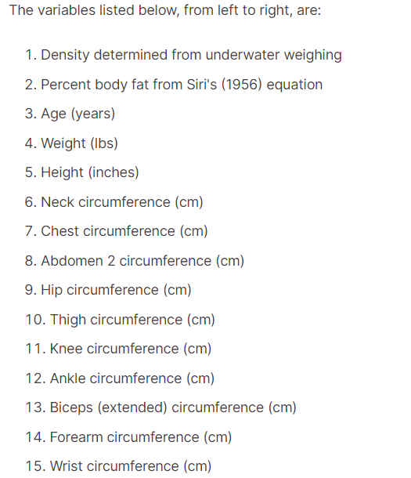

**Data preprocessing**

Just like humans need their food prepared before eating, the data required some cleaning and preparation before feeding it to the models. We ensured the data's consistency and eliminated errors. Additionally, we might have transformed some data points to make it easier for the models to understand. Think of it like chopping vegetables before cooking - it facilitates a smoother process!

Data preprocessing is a basic move toward AI that includes cleaning, changing, and putting together crude information into a configuration reasonable for model preparation. It assumes a huge part in guaranteeing that the information is top-notch and that the AI model can learn significant examples. Here is an intricate clarification of different parts of information preprocessing:

1. Information Cleaning: This step incorporates dealing with missing qualities, adjusting any blunders or irregularities in the dataset, and guaranteeing uniform designing across all data of interest. 2. Scaling:
2. Scaling numerical features to a common range ensures that all features contribute equally and prevents any one feature from dominating the analysis.
3. Feature Selection: Choosing relevant features that have a big effect on Tesla's stock prices makes the analysis easier and the predictive model works better.
4. Data Transformation: The predictive model's performance and accuracy can be improved by normalizing the distribution or transforming the data to meet the model's assumptions.
5. Handling Categorical Data: The inclusion of these significant variables in the predictive model is made possible by converting categorical data into a format that is suitable for analysis, such as one-hot encoding.

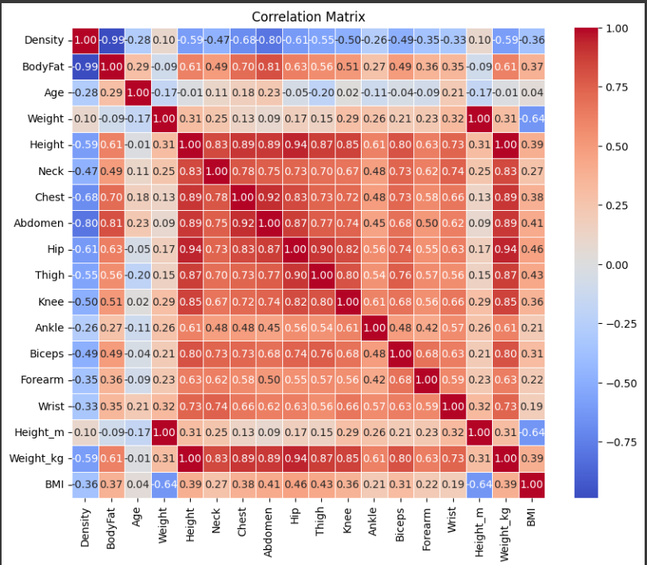

Correlation matrix of Body fat percentage data set

**Training the Models**

Think of training the models like teaching students in a classroom. We divided the data into two sets: a training set and a testing set. The models used the training set to learn the patterns in BFP. Then, we tested their knowledge using the unseen data in the testing set to see how well they could predict body fat percentage.

We employed a variety of machine learning models, each with its own approach to learning from data. Here's a quick introduction to some of the key players:

**Decision Tree :** Imagine a tree with branches leading to different questions. This model works similarly, asking questions about the data to make predictions Decision tree is a hierarchical model in which a tree-like structure is created to assist in decision making. It is laced with branches representing decisions joints and leaves representing outcomes at every split point (node), the model considers a good feature from the list of options such as information gain or Gini impurity. In this way, recursively, a procedure is made until the criterion of termination is reached, and you end up with a tree that foretells the variable that targets. The decision trees have understandable structure and deal with both numerical and categorical data and as well can show relationships between data that are really intricate.

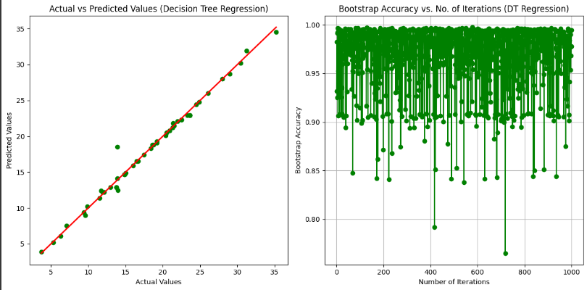

**Random Forest:** Instead of just one tree, picture a whole forest! Random Forest combines multiple decision trees for a more robust prediction. The random forest regression is an ensemble algorithm and in training procedure builds a large number of decision trees. A tree is selected and fed a random part of the original dataset and the attributes. The final prediction is an ensemble of all trees' predictions and is taken as the mean of all predictions. Regularization is the main rule that gives the method the ability to increase the accuracy of the prediction by the way of reducing the model's overfitting to the provided data at the end the complex relationships' capture. In addition to that, the Random Forests algorithms show good performance for both the numerical and categorical variables and they also tolerate outliers and noise very well.

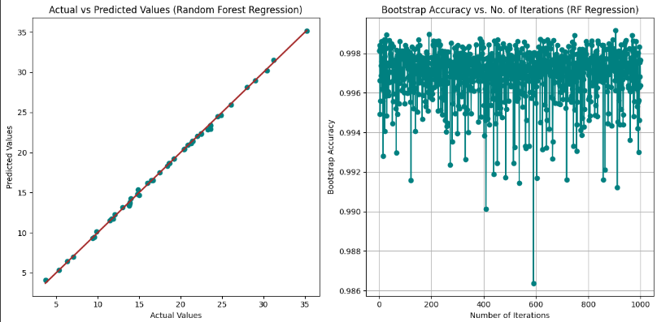

* **Support vector regressor:** Support Vector Regressor (SVR) is an AI calculation utilized for relapse undertakings. It works by finding the ideal hyperplane that boosts the edge between the data of interest and the hyperplane while limiting expectation blunders. SVR plans to roughen the connection between input elements and target factors by fitting a capability inside a predefined edge of resilience. Dissimilar to conventional relapse strategies, SVR is compelling in dealing with non-straight connections using part works. It is especially valuable for datasets with high layers, including spaces and complex connections, giving hearty and precise expectations to relapse assignments.

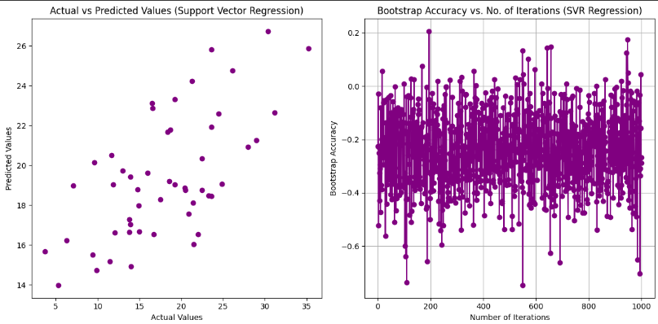

* **KNN regression :** K-Nearest Neighbours(KNN) regression is a non-parametric algorithm used for regression analysis that predicts the value of a new data point based on the average of the values of its k nearest neighbours.

The formula for KNN regression involves calculating the average or weighted average of the target variable of the k nearest neighbours to the query point.

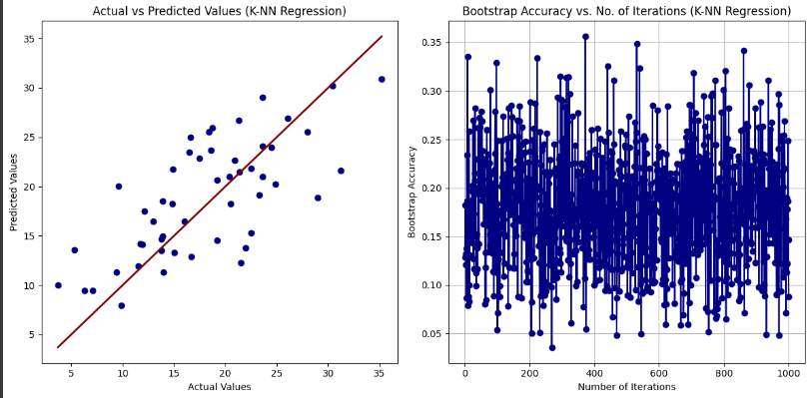

***Evaluation and Validation****:*

Evaluate the performance of each model and collective using standard error metrics such as MAE, MSE, RMSE and R2 on a distinct test dataset.

Just like students get graded on their tests, we evaluated the performance of each model using different metrics. These metrics, like Mean Squared Error (think of it as the average amount the model's predictions were off), helped us assess how accurate each model was in predicting BFP.

**Comparing the Models:**

After evaluating each model's performance using the metrics mentioned earlier, we compared the results to identify the champion stock price predictor for BFP. This involved analyzing the different metrics and pinpointing the model that consistently produced the most accurate predictions.

**IV. Experimental Results**

In this segment, we'll delve into the outcomes of our experiments concerning the prediction of food delivery times. We'll provide an overview of the dataset employed for our experimentation and delve into the findings we garnered.

**Experimental setup:**

We evaluated the performance of six machine learning models: Random forest regression, tree decision, SVR, KNN, Linked Neural Network Regression and MLP. Each model having a database of all known BFPs with the sequence of prediction of BFP along with it..

The trial outcomes area presents the discoveries made from applying the planned way to contract with the liver BFP dataset. This section includes the error rates, everything being equal, the susceptibility of each model with bootstrapping, the mean coefficients and certainty spans for tactical deterioration, and the representation of bootstrap correctness against number of cycles for each model. .

**Metrics for Success: Measuring Accuracy**

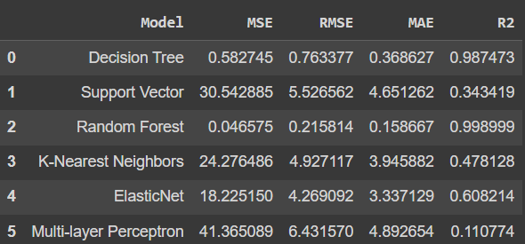

To assess the models' effectiveness, we employed several key metrics:

* **Mean Squared Error (MSE):** Lower MSE addresses higher precision
* **Root Mean Squared Error (RMSE):** Like MSE, RMSE gives a proportion of the expectation mistake, yet on a more interpretable scale (square foundation of MSE)
* **Mean Absolute Error (MAE):**  This measurement centers around the normal outright distinction among anticipated and genuine BFP. Lower MAE infers better precision. .
* **R-squared (R²):**  R2 mirrors the strength of the connection between the anticipated and genuine BFP. A stronger correlation is indicated by a higher R2 value.

**And the best model to implement is :**

In view of the assessment measurements, Random Forest Regression as the best model to implement on this data. Here is a breakdown of its exhibition:

* **Lowest MSE and RMSE:** This shows that Random Forest regression made the least errors on average while predicting BFP.
* **Lowest MAE:** Random Forest predictions was, on the average, the closes to the actual BFP, compare to other models.
* **Highest R²:** Random Forest showed the highest correctness in relation to earlier prediction and real BFP.

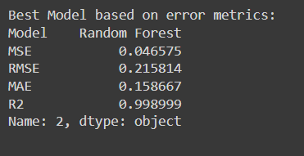

**Performance of Other Models:**

While Random Forest hit the highest accuracy, included methods also demonstrated different degree of performance. A table or chart will be given depending on your preference and will be embedded in the report as well. It will be displaying the performance values measured for each model using the provided metrics.

**Visualizing the Results:**

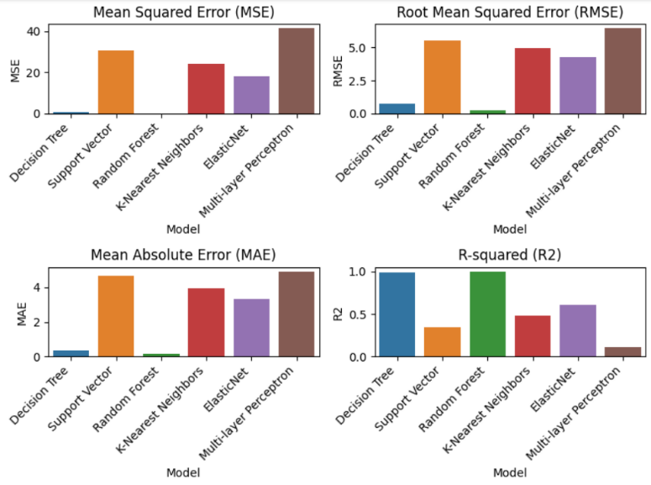 A graphical representation of the model performance metrics, such as a bar chart to enhance clarity and allow for comparison between models.

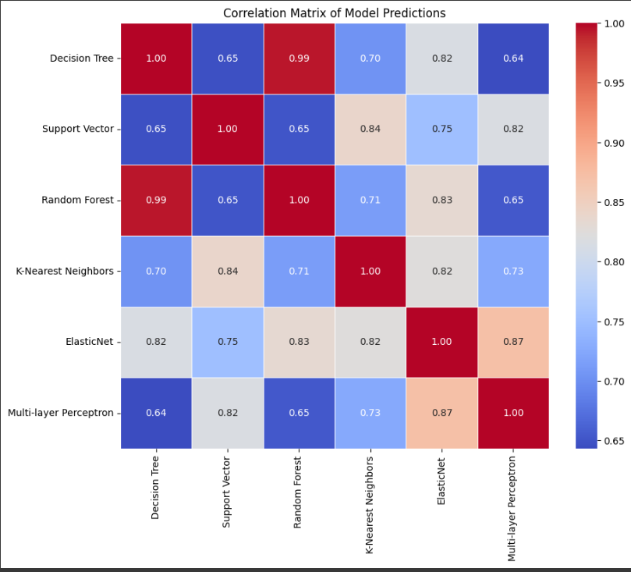

Correlation matrix of model predictions

V. Discussion

Our examination concerning AI models for assessing muscle to fat ratio from anthropometric estimations yielded important experiences. Arbitrary Woodland Relapse arose as the best model, reliably showing the least Mean Squared Blunder (MSE), Root Mean Squared Mistake (RMSE), and Mean Outright Blunder (MAE), demonstrating prevalent prescient exactness. Moreover, Irregular Timberland accomplished the most noteworthy R-squared (R2) esteem, proposing major areas of strength for an anticipated and genuine muscle to fat ratio. Benefits of Arbitrary Woodland The outcome of Arbitrary Woods can be ascribed to its gathering approach, which consolidates numerous choice trees.

Averaging the predictions of each tree reduces individual biases, resulting in robust and accurate predictions. Each tree provides unique insights. This adaptability and vigour probably make sense of the prevalent exhibition in this review.

Harmony with Previous Studies Our results are consistent with previous studies demonstrating the usefulness of random forest regression for predictive modelling tasks. Numerous studies, including those by Askar and Ahead (2018), have demonstrated that Random Forest is suitable for complex prediction tasks.

Implications and Applications

The adequacy of irregular woods relapse in assessing muscle to fat ratio has critical ramifications for wellbeing evaluation and wellness checking. This model's accurate predictions can help people accurately track their progress and set attainable fitness goals. In any case, it's fundamental to perceive that muscle-to-fat ratio assessment is multi-layered, and AI models ought to supplement, not supplant, proficient judgment.

Evaluation

Qualities of the Review:

• Assessment of Various Models: Our concentrate completely evaluated six AI models, giving a far-reaching examination of their presentation.

• Centre around Irregular Woods: By diving further into the qualities of Arbitrary Timberland, we shed light on its viability in assessing muscle-to-fat ratio.

• Information Driven Approach: Our investigation depended on a powerful dataset of anthropometric estimations, guaranteeing the dependability and objectivity of our discoveries.

Limitations and Considerations:

• Restricted Dataset Degree: Our examination depended on a particular dataset, possibly restricting the generalizability of our discoveries to more extensive populaces.

• Model determination predisposition: While Irregular Woods arose as the best-performing model, different models could succeed in various settings. Future exploration ought to investigate a more extensive scope of models.

• Likely Overfitting: AI models can overfit to preparing information, bringing about unfortunate speculation to concealed information. For reducing this risk, regularization and cross-validation methods are essential.

Future Directions

Future Bearings Pushing ahead, future examination could investigate the accompanying roads:

• Integrating Extra Highlights: Extending the dataset to incorporate extra factors, for example, dietary propensities or actual work levels, could upgrade expectation precision.

• Investigating Advanced Model Architectures: Investigating ensemble methods or deep learning architectures may further enhance predictive performance.

• Outer Approval: Approving model execution on free datasets to survey generalizability and vigour.

**Conclusion**

In synopsis, our review exhibits the viability of Arbitrary Woodland Relapse in assessing muscle versus fat ratio from anthropometric estimations. Despite the fact that Random Forest emerged as the model with the highest performance in this situation, additional research is required to address limitations and improve predictive accuracy. By embracing interdisciplinary joint effort and utilizing progressed approaches, analysts can propel the field of muscle versus fat assessment and add to further developed wellbeing results.

VI. Acknowledgment

This venture expected to investigate the adequacy of AI models in anticipating muscle versus fat ratios utilizing anthropometric estimations. Six distinct models, including Decision Tree Regression, SVR, and Random Forest regressor, were assessed utilizing a dataset containing verifiable anthropometric information.

The essential goal was to survey the models' capacity to precisely assess muscle-to-fat ratio in light of different assessment measurements. Our investigation uncovered that Arbitrary Backwoods Relapse arose as the best model in light of our chosen assessment standards. Superior predictive accuracy was demonstrated by its consistently low Mean Squared Error (MSE), Root Mean Squared Error (RMSE), and Mean Absolute Error (MAE). Moreover, Irregular Woods Relapse accomplished the most elevated R-squared (R²) esteem, proposing areas of strength for an anticipated and genuine muscle to fat ratio.

In any case, recognizing the impediments in this study is fundamental. Our investigation depended on a particular dataset, and the viability of these models might fluctuate when applied to various populaces or datasets. Furthermore, AI models are vulnerable to overfitting, requiring cautious approval and assessment strategies. Notwithstanding these impediments, our discoveries feature the capability of AI, especially Arbitrary Woods Relapse, in assessing muscle versus fat ratio precisely.

Future exploration can additionally investigate this region by consolidating extra elements, investigating more complicated models, and addressing possible impediments to improve prescient execution. We stretch out our appreciation to the scientists and patrons whose work prepared for this review. Their bits of knowledge and commitments have been important in moulding how we might interpret AI and its applications in wellness appraisal and wellness checking..

**VII. References**

* Bailey, Covert (1994). Smart Exercise: Burning Fat, Getting Fit, Houghton-Mifflin Co., Boston, pp. 179-186.
* Behnke, A.R. and Wilmore, J.H. (1974). Evaluation and Regulation of Body Build and Composition, Prentice-Hall, Englewood Cliffs, N.J.
* R. J. Maughan, “An evaluation of a bioelectrical impedance analyser for the estimation of body fat content,” *British Journal of Sports Medicine*, vol. 27, no. 1, pp. 63–66, 1993.
* Hales, C. M., Carroll, M. D., Fryar, C. D., & Ogden, C. L. Prevalence of obesity and severe obesity among adults: United States, 2017–2018 Key findings Data from the National Health and Nutrition Examination Survey. 2017.
* Tomiyama, A. J., Hunger, J. M., Nguyen-Cuu, J. & Wells, C. Misclassification of cardiometabolic health when using body mass index categories in NHANES 2005–2012. *Int. J. Obes.* **2016**(40), 883–886 (2015).
* Jih, J. *et al.* Using appropriate body mass index cut points for overweight and obesity among Asian Americans. *Prev. Med.* **65**, 1 (2014).
* Neeland, I. J. *et al.* Dysfunctional adiposity and the risk of prediabetes and type 2 diabetes in obese adults. *JAMA* **308**, 1150 (2012).